**Build instructions for 3D-printed microscopes of PHASE2022 workshop**

The instructions in this document are meant to guide any user through the assembly and function test of a simple 3D-printed microscope system with an automated xyz stage and matrix LED illumination. All required build parts will be listed, followed by a step by step guide for the assembly including test points to check all connections are working.

**Part list:**

3D-printed elements: (Designs for all parts can be found here: github…)

* Microscope frame
* Electronics base
* Optics unit
* Camera mount (includes glued on RaspberryPi zero camera)
* Z-axis runner and optics unit connector
* Top cover
* Sample holder
* Sample holder clips (x2)
* Illumination holder(includes screwed on 11x7 matrix LED)

Active elements and optics:

* 2-axis stage for xy movement (with colour coded connection wires)
* Geared stepper motor 28BYJ-48 for z movement
* M3 leadscrew attached to 3D-printed adapter for stepper motor
* 11x7 matrix LED board (connected to 3D-printed part)
* RaspberryPi zero camera (connected to 3D-printed part)
* Plan-convex lens f=50mm, diameter ½”
* X40 economy microscope objective
* MGN12 rail with MGN12H rail runner

Electronics:

* RaspberryPi zero
* ULN2003 stepper motor driver for z-axis geared stepper
* L9110S stepper motor driver for xy-axis (x2)
* RaspberryPi pin connector for control of all drivers

Screws, tools and assorted:

* M2.5 hex key
* M3 hex key
* Flat-head screwdriver
* M2.5x6 screws (14x)
* M3x12 screws (16x)
* M3x6 screws (4x)
* M3 nuts (12x)
* USB cable
* Imaging target

**General Preparation:**

Before starting the build process please download the below programs onto the PC/laptop you will be using to control the microscope. This will allow you to create a remote connection via the provided USB cable to the raspberry pi zero.

* VNC viewer

<https://www.realvnc.com/en/connect/download/viewer/>

(Used to create graphical remote desktop connection to a raspberry Pi – please download the version appropriate for your operating system)

* RNDIS driver

Github …

(Used to recognise the Pi as a remote access device and not just mass storage; depending on your laptop/PC this might not be necessary)

**Check that Raspberry Pi is recognised correctly in the system**

1) Start by connecting the Raspberry Pi zero to your laptop/PC using the provided USB cable. Make sure to connect to the left/inner USB port (labelled “USB”) and not to the right/outer USB port (labelled “PWR”)

2) Open VNC viewer

3) Create a new connection “File -> New connection”

VNC server: raspberrypi.local

Name: PiZero

4) Double click on the connection to try to connect to the Raspberry Pi (You will have needed to wait for ~2-3min, until the Raspberry Pi has fully booted)

5) If the program asks for a username and password, use **“pi” as username** and **“raspberry” as password**. Steps 6) - ? are not needed in this case.

6) If an error reading “No such host is known” is coming up you will need to install an additional driver for the Raspberry Pi

7) Open the device manager “Windows key -> device manager”

8) Under ?? right click on the COM port that is displayed for your Raspberry Pi

9) Click “update driver”

10) Browse to the folder you have saved the RNDIS files from above

11) select this location for the new driver to be found

12) This will install a new USB Ethernet/RNDIS Gadget which should now be under “Network adapters” in the device manager.

13) Try again to connect via VNC using the username and password above.

**Check that all motors and electronics are working**

Before assembling the mechanical parts of the microscope, check that all electrical connections work.

**Items needed:**

* Raspberry Pi
* USB cable
* Pin-header connection cable
* 11x7 LED board
* Geared stepper motor 28BYJ-48 including driver board
* L9110S stepper motor driver (x2)
* 2-axis stage for xy movement (with colour coded connectors)

1) Connect *Pin-header connection cable* to *Raspberry Pi*

Make sure end with white marker is pointing towards SD card holder

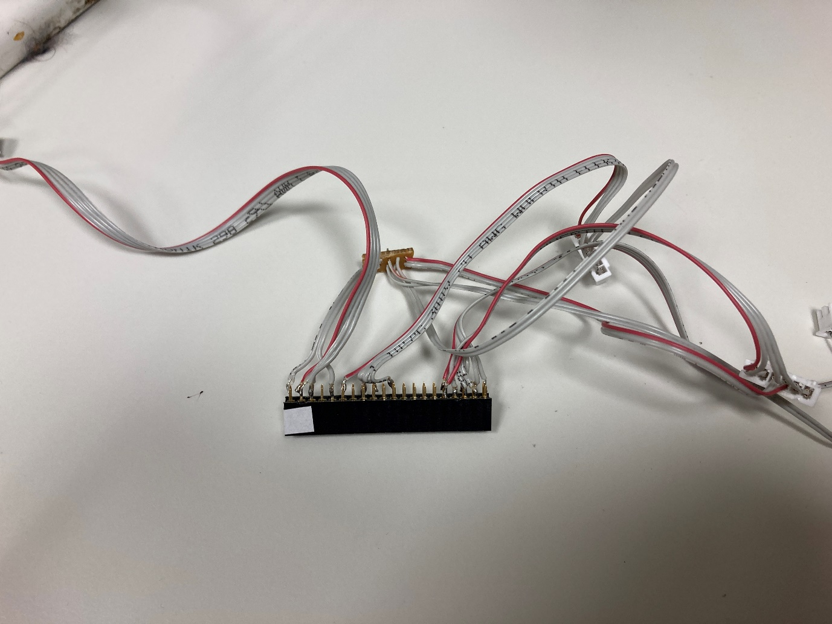 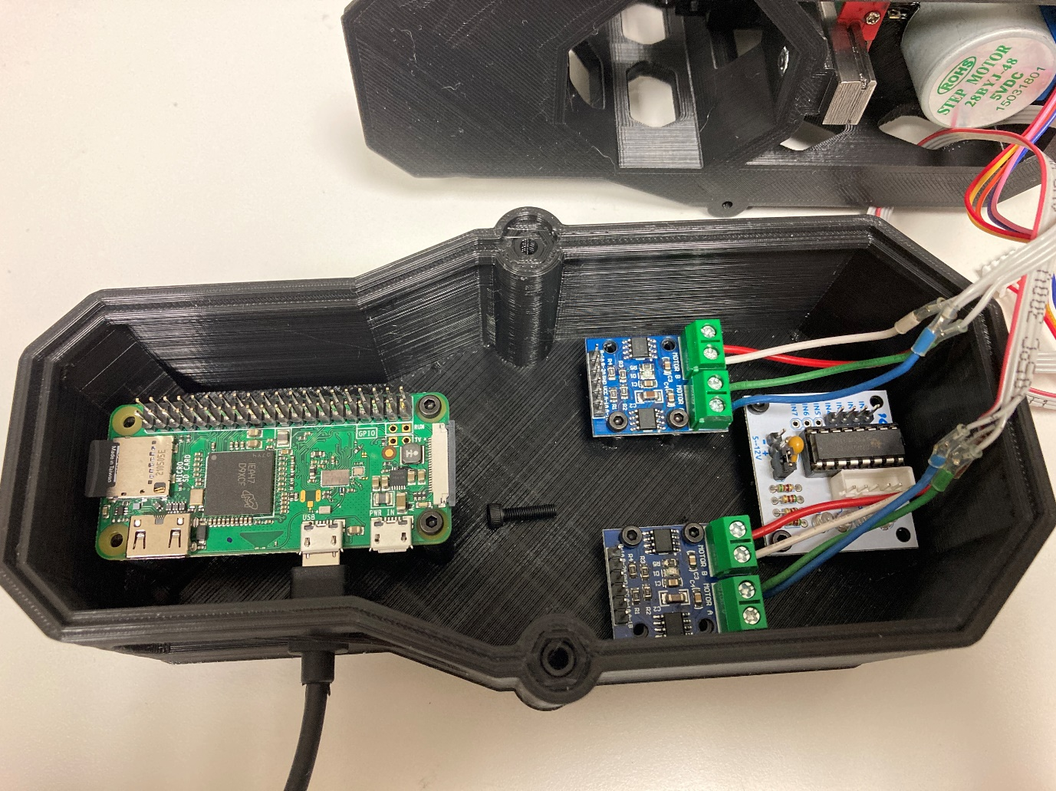

2) Connect 5-pin connector from *Pin-header connection cable* to *11x7 LED board*

The red-marked wire should connect to the “3-5V” connection on the *11x7 LED board*

3) Connect *28BYJ-48 stepper motor* to its *z stepper motor driver board*

4) Connect 4-pin connector from *Pin-header connection cable* to pins In1-In4 on *z stepper motor driver board*

Make sure that red-marked wire is connected to In1

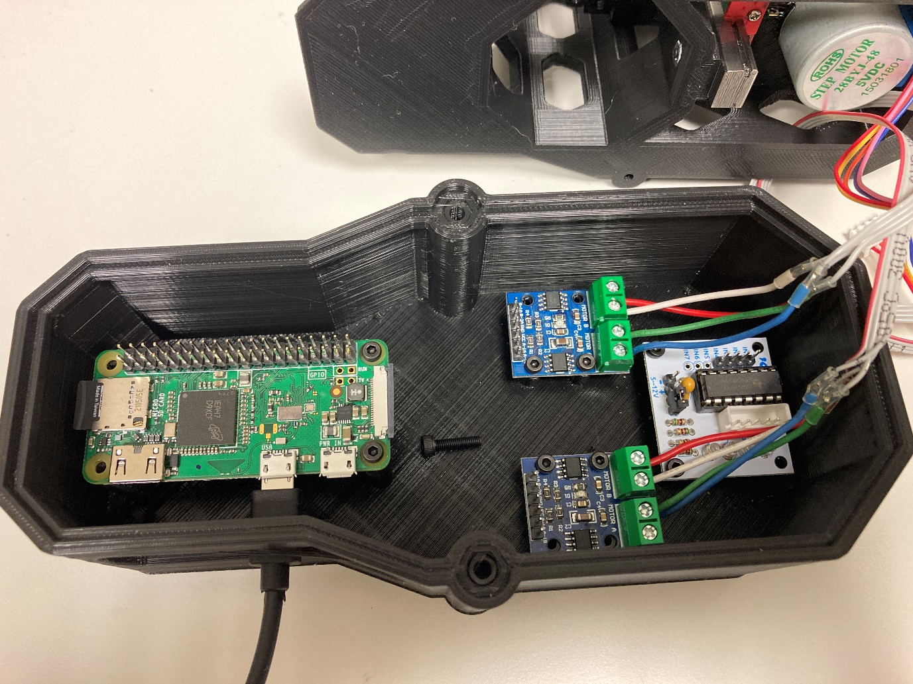

5) Connect 2-pin connector from *Pin-header connection cable* to 5-12V input on *z stepper motor driver board*

Make sure that the red-marked wire is connected to the “+” marked pin

6) Connect both of the two 6-pin connectors from *Pin-header connection cable* to one of the *L9110S stepper motor driver* each

Make sure the red-marked wire on the 6-pin connector is connected to B-1A

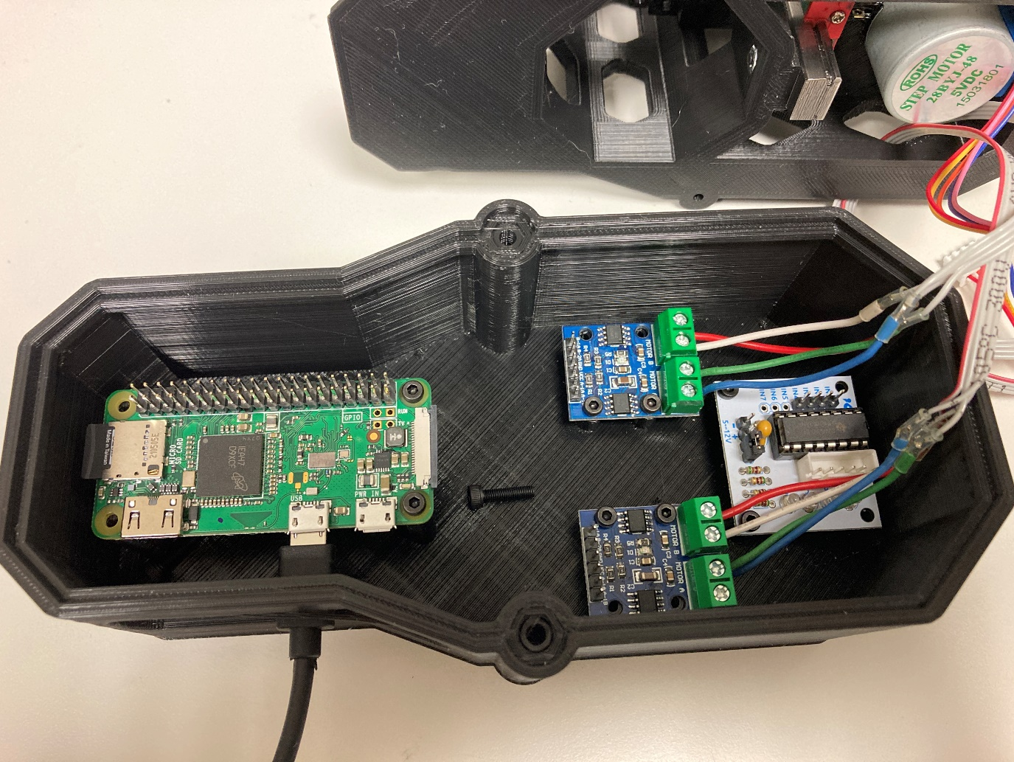

7) Connect the colour coded wires from the *2-axis stage for xy movement* to the *L9110S stepper motor drivers*

The wire order is as in the picture above: red, white, green, blue (from top to bottom)

Screw the wires tightly in the screw terminals to create a stable connection

8) Connect the *USB cable* to the Raspberry Pi USB port and to your Laptop/PC

9) Wait for the Raspberry Pi to be booted up (~2min)

10) Open VNC viewer and connect to the PiZero following the instructions under “General Preparation”

11) Open a terminal in the Ubuntu environment on the remote connection

12) Navigate to the folder with the workshop python code

“cd Workshop”

13) Start the GUI for controlling the microscope

“python3 Start.py”

14) Check that no errors appear and the GUI loads

15) If errors appear please let one of the instructors know and we will help you trouble shoot the reason.

16) Move the slider for the Illumination to check power of the *11x7 LED board*

17) Click on the double up arrow for the z-axis and check that the *z-stepper motor* turns (indicated by all red LEDs of the driver board blinking)

18) Click on the double up arrow for the xy-axes and check that one of the two axes of the *2-axis stage for xy movement* moves

19) Click on the double left arrow for the xy-axes and check that the other of the two axes of the *2-axis stage for xy movement* moves

20) If either of the 3 axes do not move, please let one of the instructors know and we will help you trouble shoot the reason.

21) Disconnect all parts again after a successful test.

**Assembly of 3D-printed microscope**

The following steps will guide you through the full assembly of the 3D-printed microscope. If at any point anything is unclear or does not seem to work please let one of the instructors know.

**As some of the parts are relatively small and thin, care should be taken at every step and no excessive force should be used.**

The assembly can be split up when assembling the setup with multiple people; a natural split is 1 person/group assembling the optics unit and electronics base while a second person/group is assembling the stage system and main body

**Assembly of Optics Unit and Electronics Base**

1) Connect the 3D-printed *Optics housing* with the *Camera base*

Align the camera so that the camera cable is facing the curved side of the Optics housing

Use four M3x12 screws to connect the two parts

Make sure all four screws are fully set (at times there can be quite a lot of resistance)

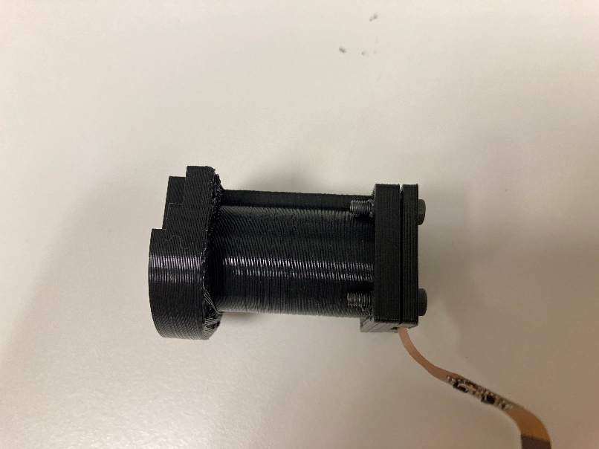 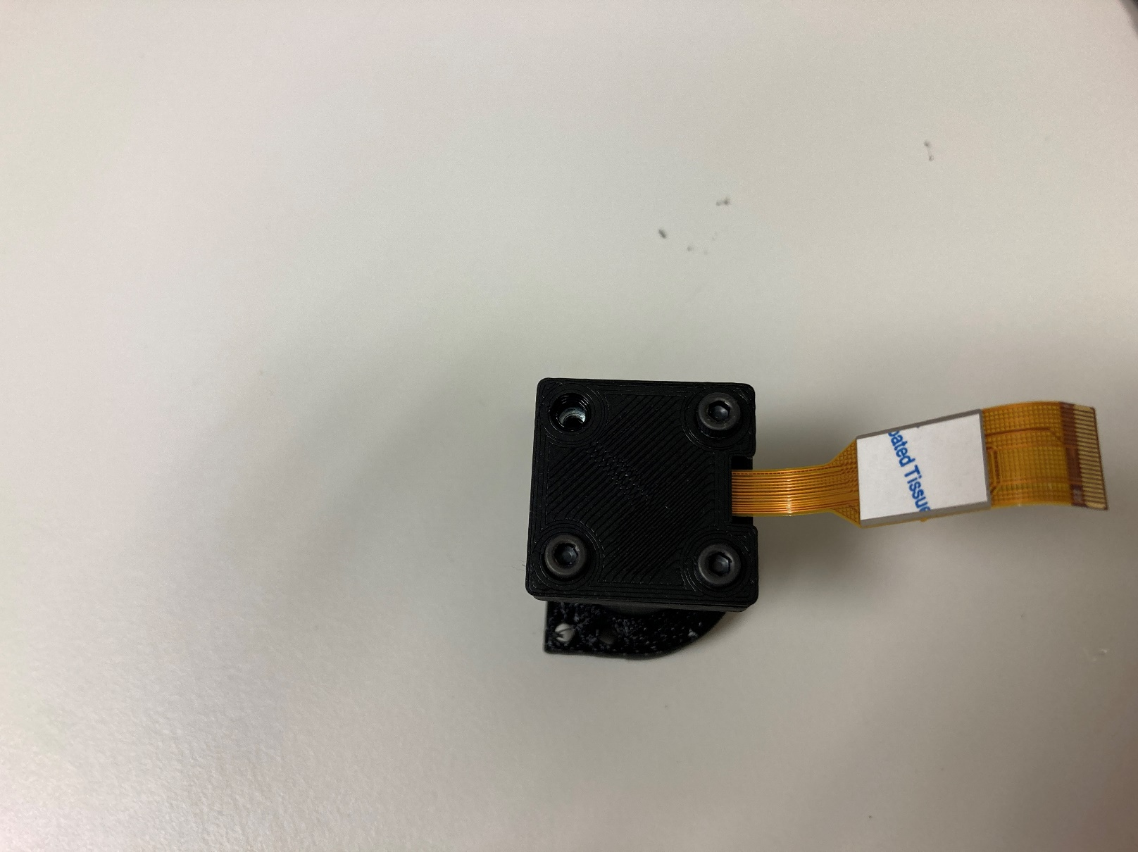

2) Place the *f=50mm lens* (Thorlabs lens box) into the *Optics housing*

Align the flat side of the lens to point down towards the camera

Make sure to either touch the lens only on the rim, or wear gloves to not leave marks on the lens surfaces

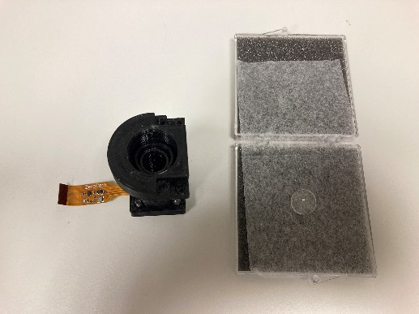 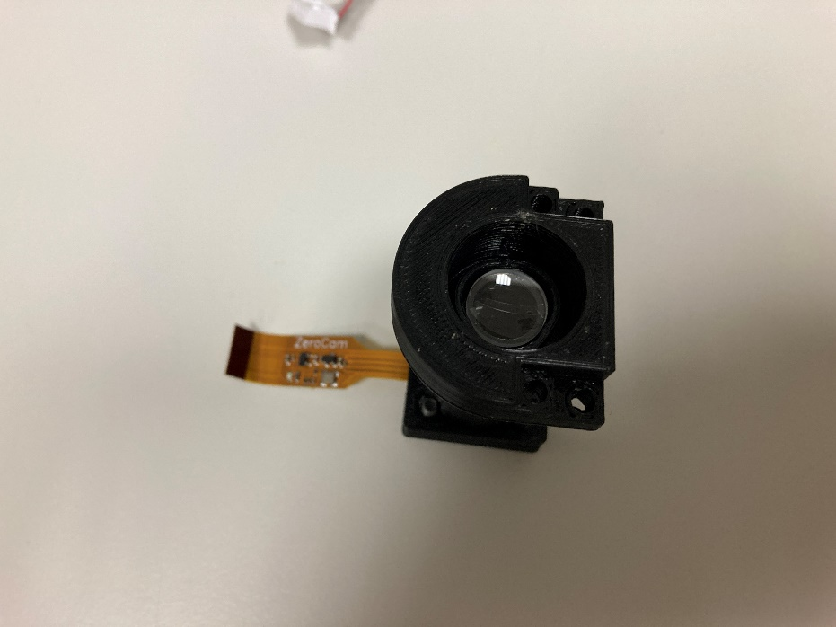

3) Leave aside until the final assembly step

4) Connect the *USB cable* to the *Raspberry Pi* USB port

5) Mount the *Raspberry Pi* and the three stepper motor driveronto the *Base 3D-print* using four M2.5x6 screws each

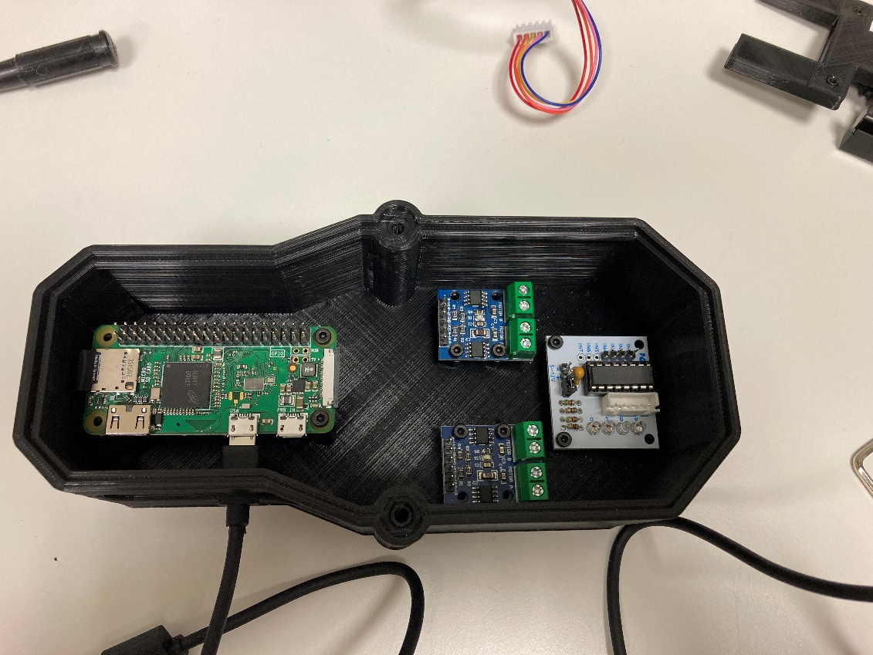

6) Connect the *Pin header connection cable* to the *Raspberry Pi*

7) Connect the 6-pin connectors from the *Pin header connection cable* to the two *L9110S* driver boards

Make sure that the red-marked cable connects to B-1A

8) Connect the 4-pin connector from the *Pin header connection cable* to the *z-axis stepper motor driver*

Make sure that the red-marked cable connects to In1

9) Connect the 2-pin connector from the *Pin header connection cable* to the *z-axis stepper motor driver*

Make sure that the red-marked cable connects to “+”

**Assembly of Stage System and Main Body**

1) Connect the *z-axis rail* to the *Main Body* 3D-print

Use at least two M3x12 screws and two M3 nuts

The screw head needs to be on the rail side, and the nut in the cut out on the 3D-print

Tighten fully after having both screws in place to get the vertical alignment

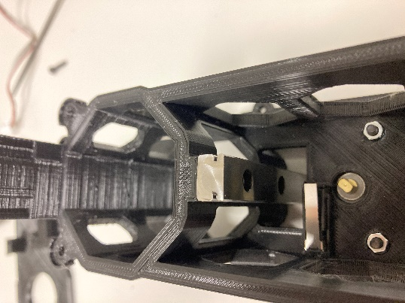 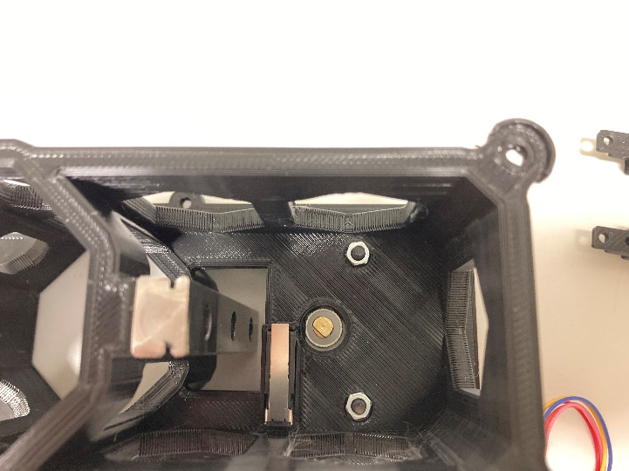

2) Connect the *z-axis stepper motor* onto the *Main Body* 3D-print

Make sure the motor is oriented as shown in the image below

Use two M3x12 screws and two M3 nuts

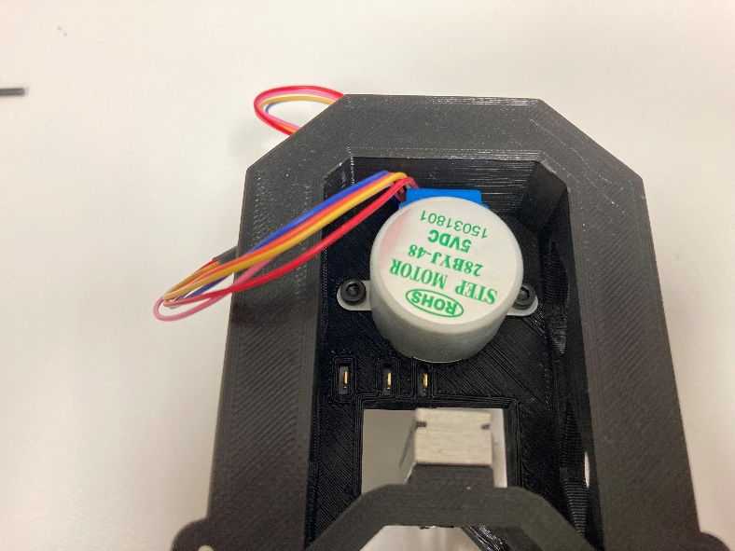 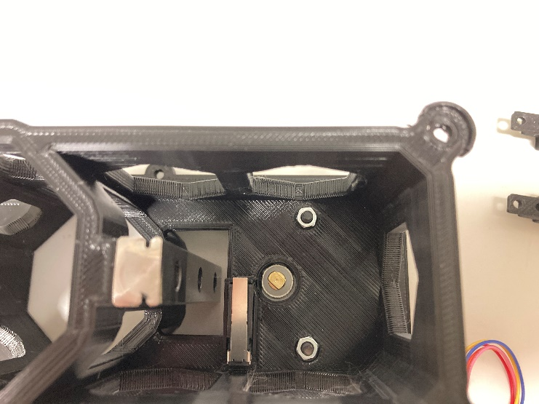

3) Put an M3 screw on the *M3 lead screw* and insert into the 3D-printed *rail-runner connector*

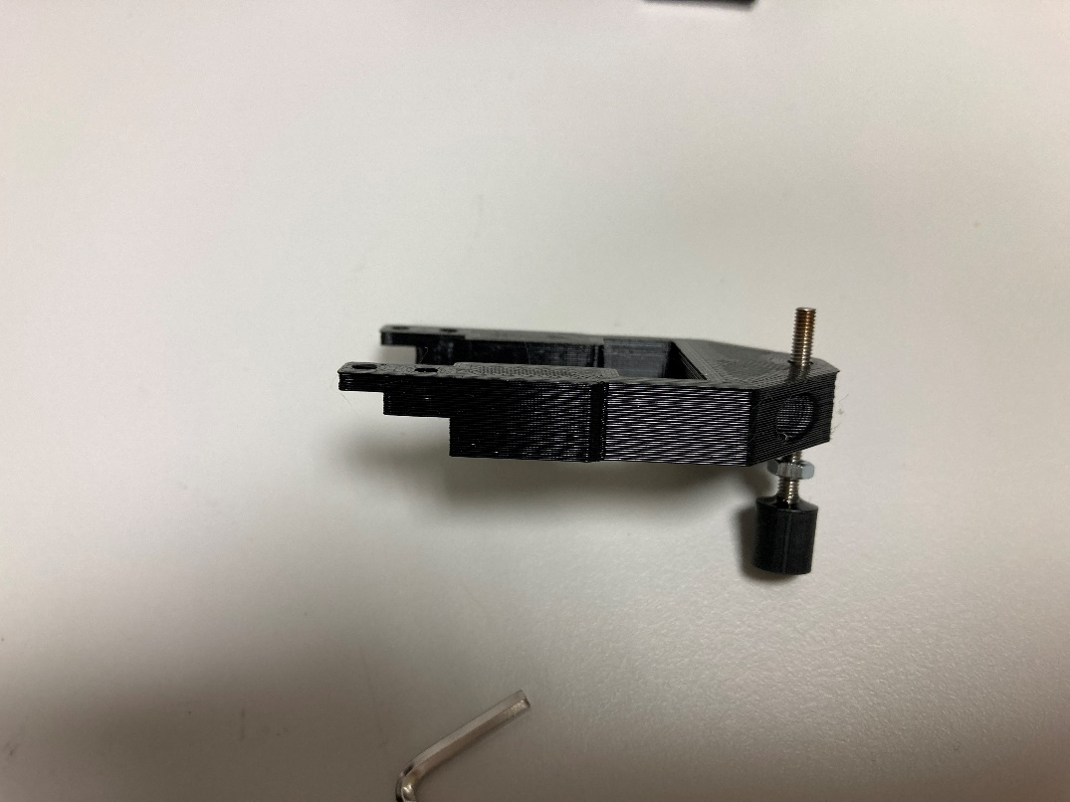 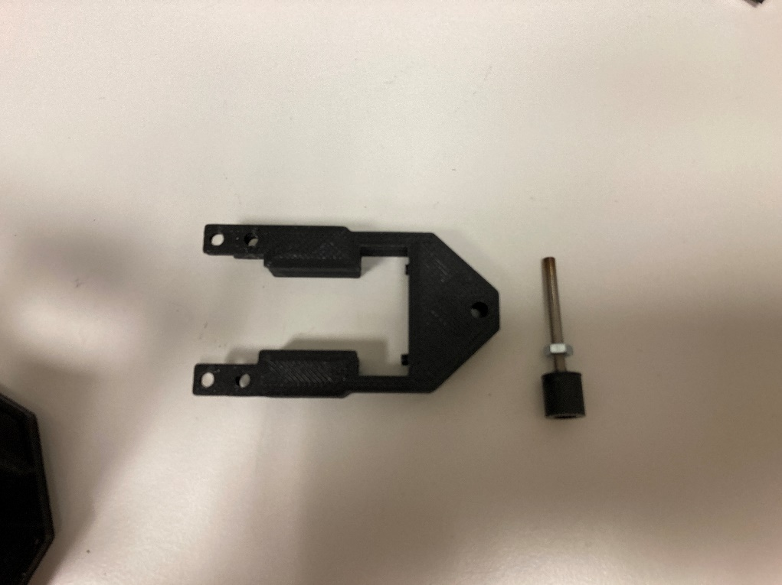

3) Place the *M3 lead screw* and connector on the *z-axis motor* rotor

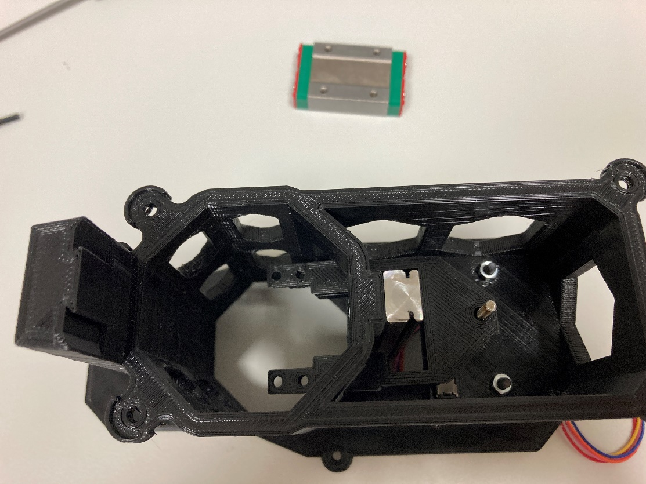

4) Slide the *rail runner* onto the rail and through the hole in the *M3 lead screw connector*

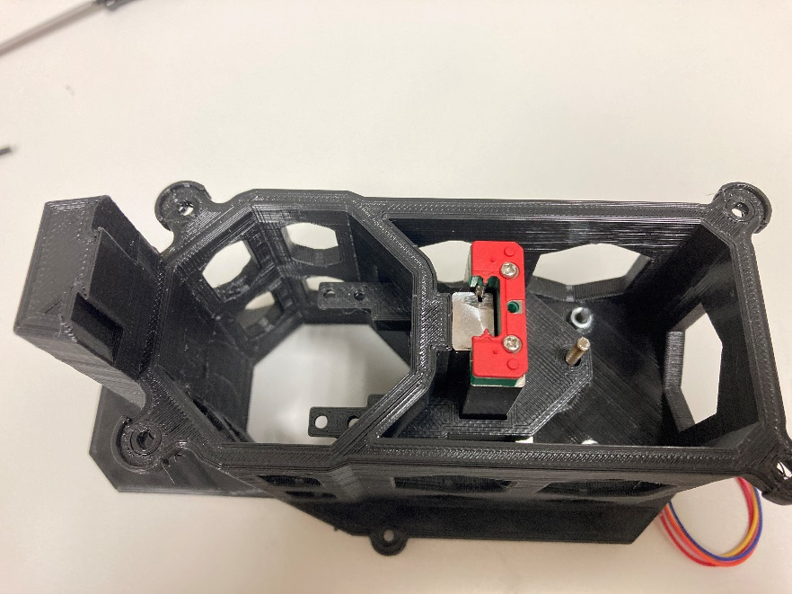

5) Connect the *M3 lead screw connector* to the *rail runner* using two M3x6 screws

Make sure to connect the top two holes on the *rail runner*

The M3 screws need to feed through the holes on the side of the *M3 lead screw connector*

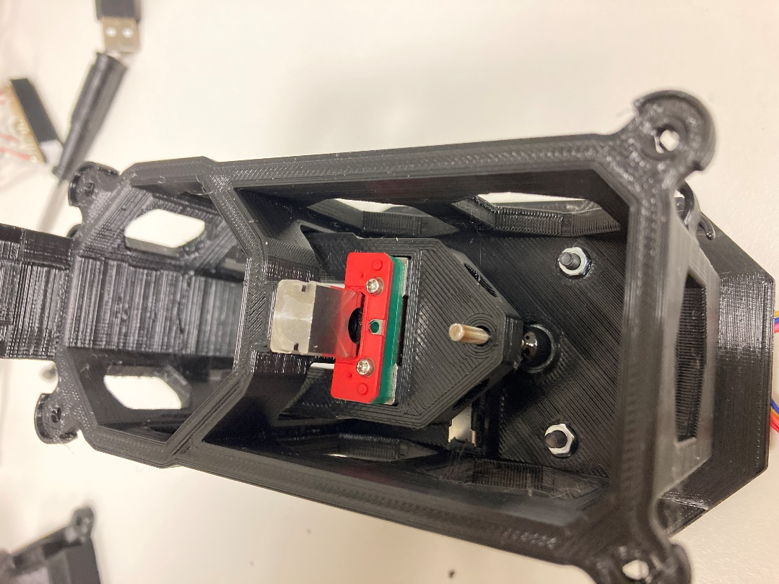 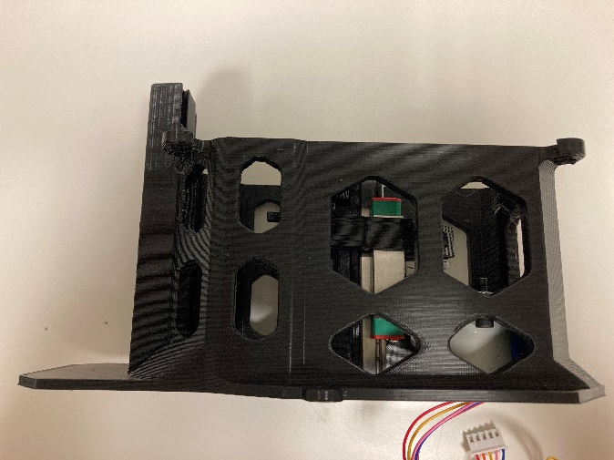

**This completes the assembly of the two individual parts, with the overall system now needing to be connected.**

1) Place the *Base 3D-print* and the *Main Body* part next to each other

2) From the *Pin header connection cable* feed the 5-pin connector through the bottom left hole on the *Main Body* (see left side of below image)

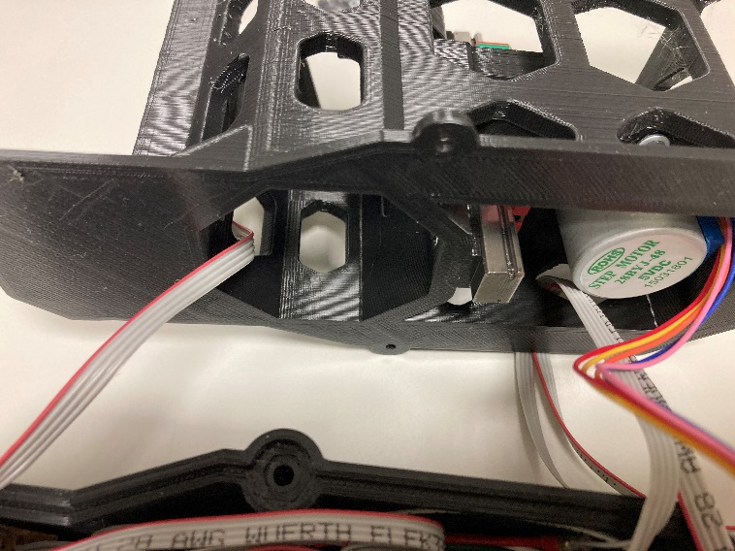

3) From the *2-axis stage for xy movement* feed the wires with the colour coded ends through the bottom right hole on the *main body* (see right side of above image). The coloured ends should go past the stepper motor.

4) Connect the 4 colour coded wires of the *2-axis stage for xy movement* to the two *L9110S stepper motor driver*

The order should be red, white, green blue (from top to bottom)

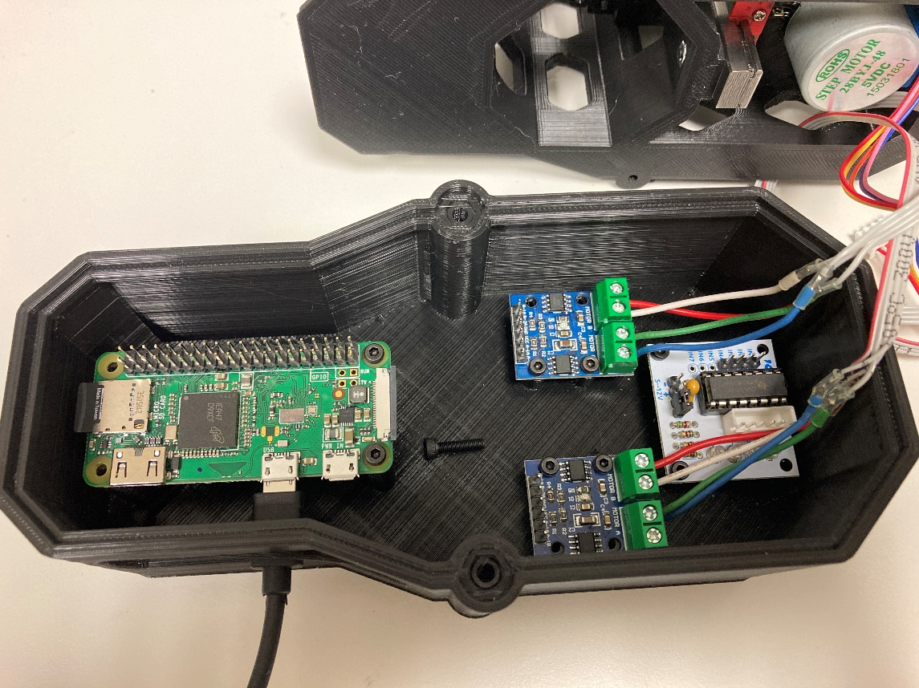

5) Connect the *camera cable* of the *Optics Unit* to the camera port of the *Raspberry Pi*

Make sure the electrical contacts of the cable face down

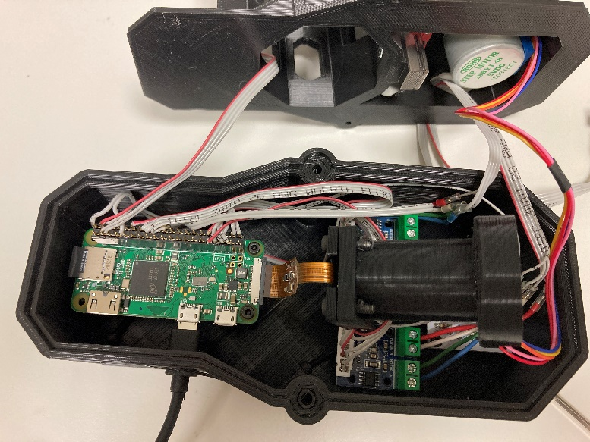

6) Feed the *Optics Unit* through the *Main Body* when placing it on the Electronics Housing

7) Use two M3x12 screws to fix the *Optics Unit* onto the *M3 lead screw connector*

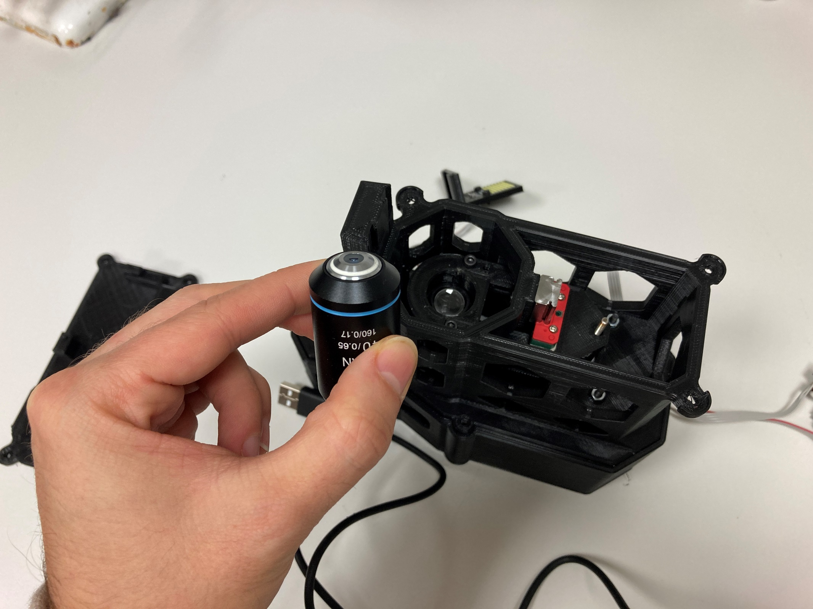

8) Carefully screw the *40x microscope objective* into the *Optics Unit*

Make sure to screw the objective in flat to not cross-thread the connection

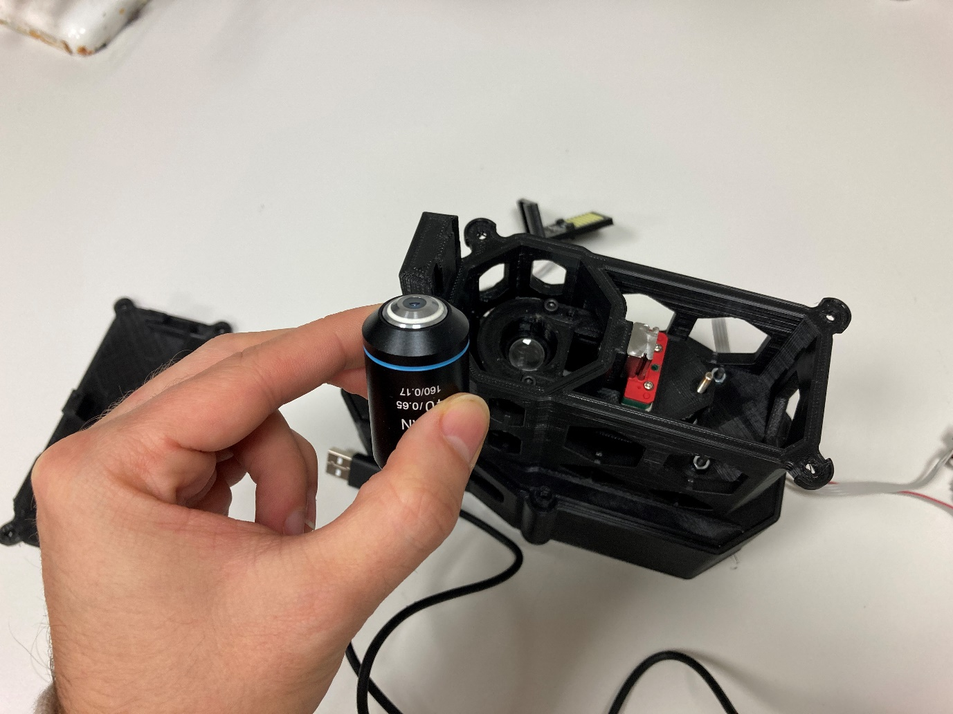

9) Connect the 5-pin connection of the *pin header connection cable* to the *11x7 LED* and the *Sample holder* to the top of the *2-axis stage for xy movement*

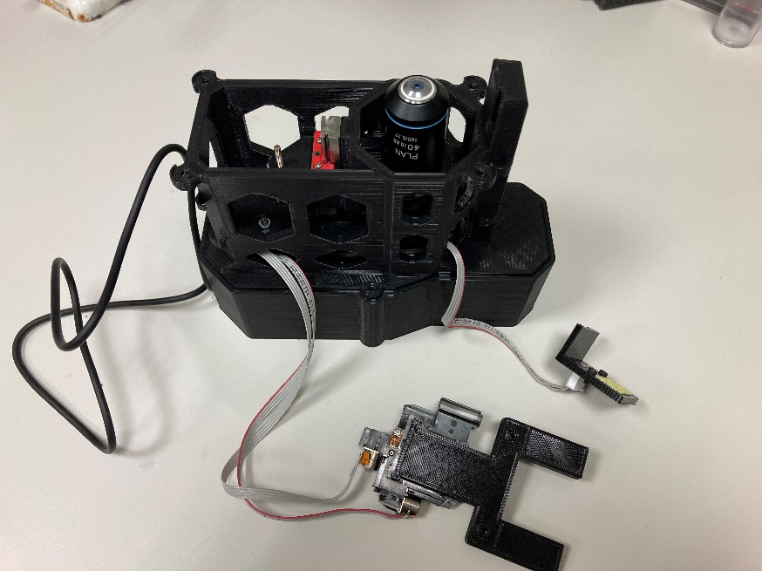

10) Connect the *top cover* onto the *Main body* and fit the *2-axis stage for xy movement* onto the *top cover*. Finish by connecting the *11x7 LED* unit onto the *Main body*

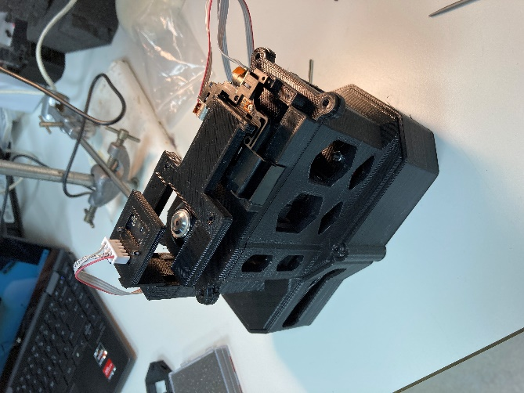

**Final assembled setup:**

